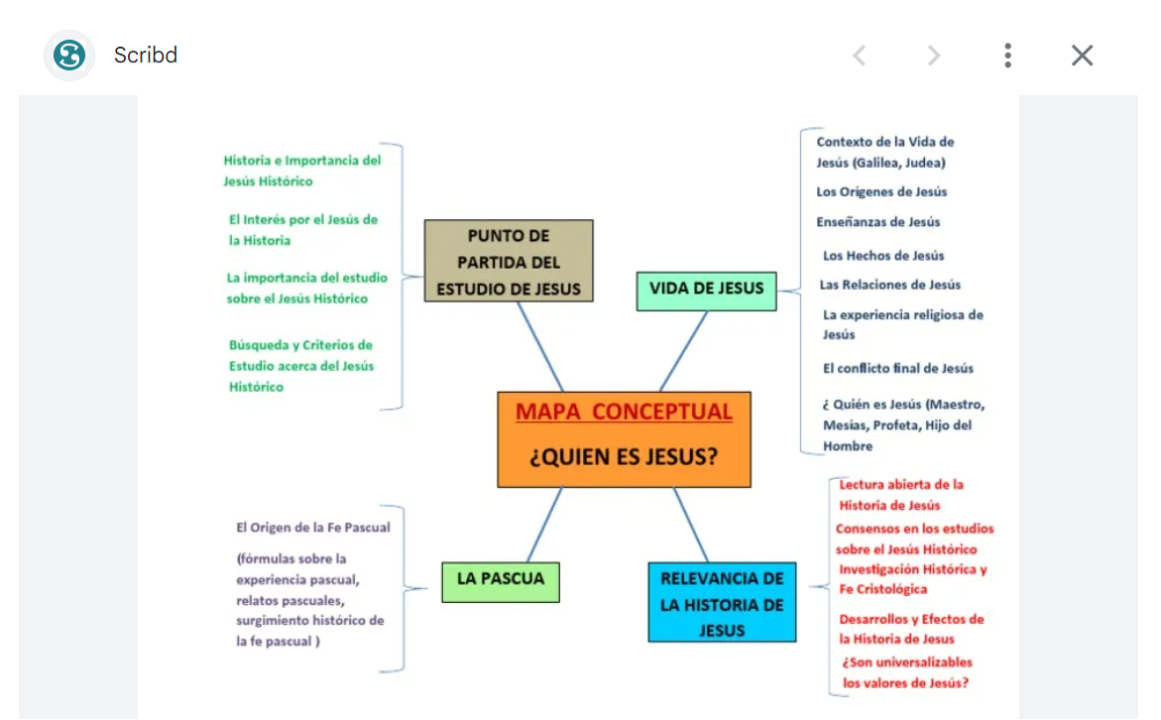

Fuentes: https://images.app.goo.gl/H3cB4DkFuCdprsku6. https://images.app.goo.gl/MGih15jQF5vhoeNv7.

